1.create database Library_Management_System;
use Library_Management_System;

create table members(
member_id int primary key,
first_name varchar(100) not null,
last_name varchar(100) not null,
dob date,
email varchar(255) not null unique,
phone varchar(20),
street varchar(255),
city varchar(100),
state varchar(50) default "Tamil Nadu",
zip_code varchar(10),
membership_type varchar(20) not null check (membership_type in ('Basic','Premium','VIP'))
);

create table categories(
category_id int primary key,
category_name varchar(150) not null unique,
description varchar(500)
);

create table books (
book_id int primary key,
title varchar(255) not null,
author varchar(200) not null,
isbn varchar(20) not null unique,
publisher varchar(200),
pub_year int,
price decimal(10,2) not null,
total_copies int not null default 1,
category_id int not null,
constraint fk_category
foreign key (category_id)
references categories(category_id)
);

create table borrows (
borrow_id int primary key,
member_id int not null,
book_id int not null,
borrow_date date not null,
due_date date not null,
return_date date,
status varchar(20) not null check (status in ('Borrowed','Returned','Overdue')),
constraint fk_book
foreign key (book_id)
references books(book_id),
constraint fk_member
foreign key (member_id)
references members(member_id)
);

create table fines (
fine_id int primary key,
borrow_id int not null,
member_id int not null,
fine_amount decimal(10,2) not null,
paid_amount decimal(10,2) default 0,
fine_date date not null,
payment_status varchar(20) not null check (payment_status in ('paid','unpaid','waived')),
constraint fk_fines_borrow
foreign key (borrow_id)
references borrows(borrow_id),
constraint fk_fines_member
foreign key (member_id)
references members(member_id)
);

insert into members(member_id, first_name, last_name, dob, email, phone, street, city, state, zip_code, membership_type) values
(1, 'Jagadeep', 'K C', '2004-05-12', 'jagu@gmail.com', '9876543210', 'Anna Nagar', 'Chennai', 'Tamil Nadu', '600040', 'Basic'),
(2, 'Gowtham', 'Raja', '2004-08-20', 'gow@gmail.com', '9123456780', 'T Nagar', 'Chennai', 'Tamil Nadu', '600017', 'Premium'),
(3, 'Hari', 'Prasath', '2005-01-15', 'hari@gmail.com', '9012345678', 'Velachery', 'Chennai', 'Tamil Nadu', '600042', 'VIP');

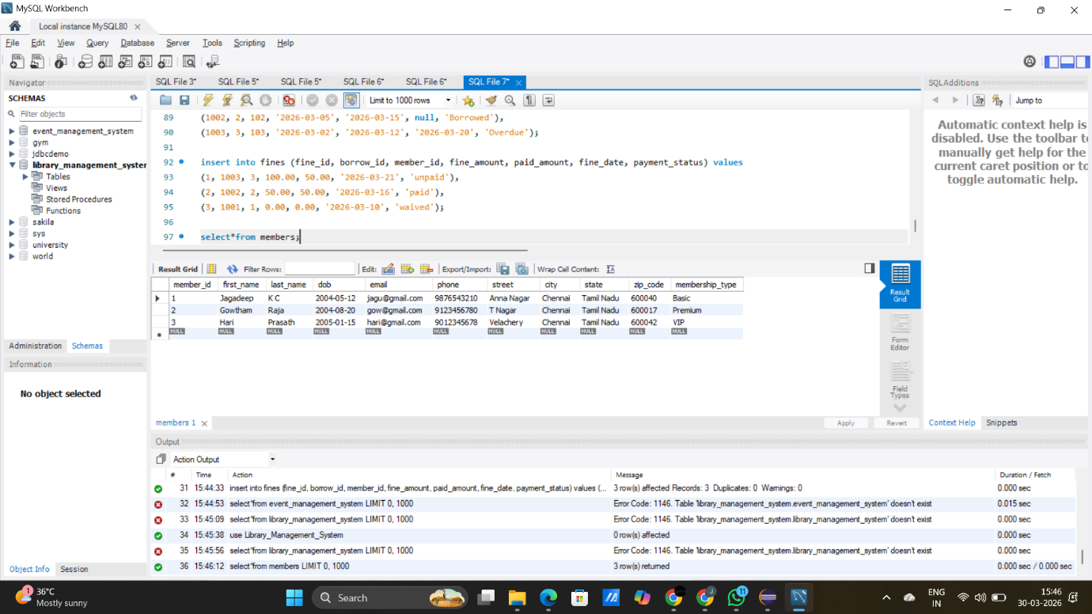

insert into categories(category_id, category_name, description) values
(1, 'Sports', 'A books'),
(2, 'Education', 'Academic and study books'),
(3, 'Technology', 'Tech related books');

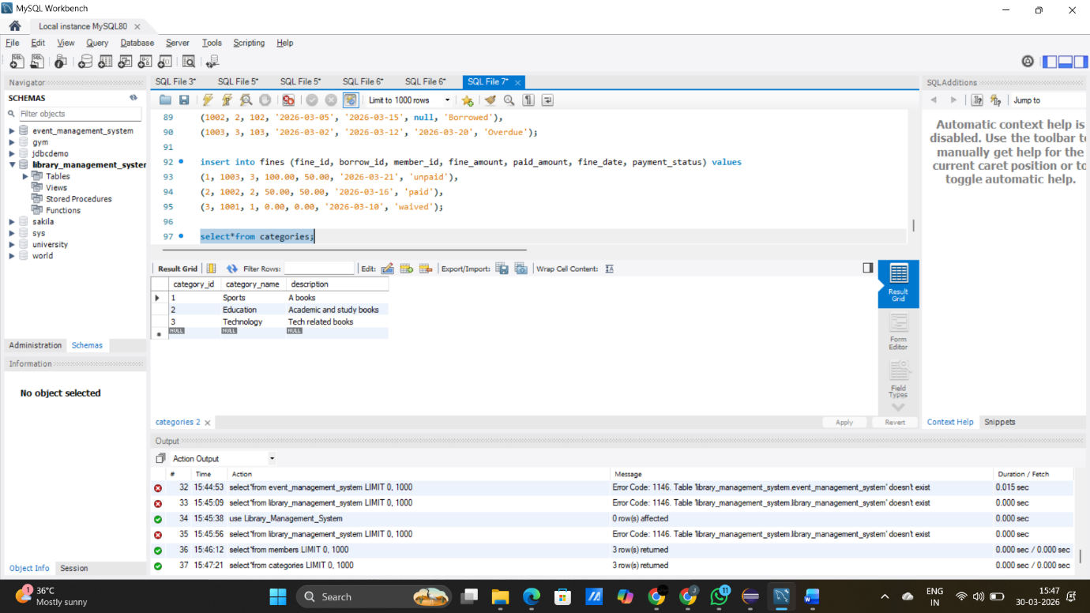

insert into books (book_id, title, author, isbn, publisher, pub_year, price, total_copies, category_id) values
(101, 'Harry Potter', 'J K Rowling', 'ISBN001', 'Darshan', 1988, 399.99, 5, 1),
(102, ' Learn Chess', 'V.Anand', 'ISBN002', 'Ashok', 2015, 599.50, 3, 2),
(103, 'Java Programming', 'Darshan Raj', 'ISBN003', 'Anand', 2018, 699.00, 4, 3);

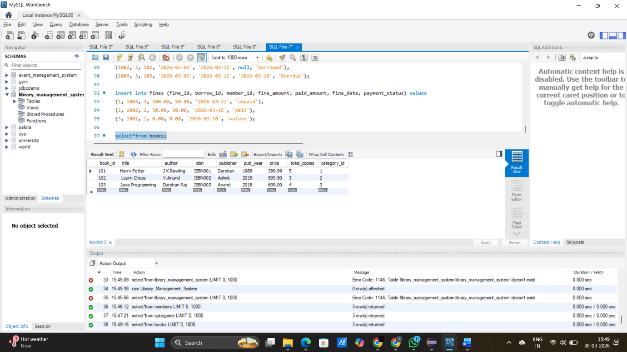

insert into borrows (borrow_id, member_id, book_id, borrow_date, due_date, return_date, status) values
(1001, 1, 101, '2026-03-01', '2026-03-10', '2026-03-09', 'Returned'),
(1002, 2, 102, '2026-03-05', '2026-03-15', null, 'Borrowed'),
(1003, 3, 103, '2026-03-02', '2026-03-12', '2026-03-20', 'Overdue');

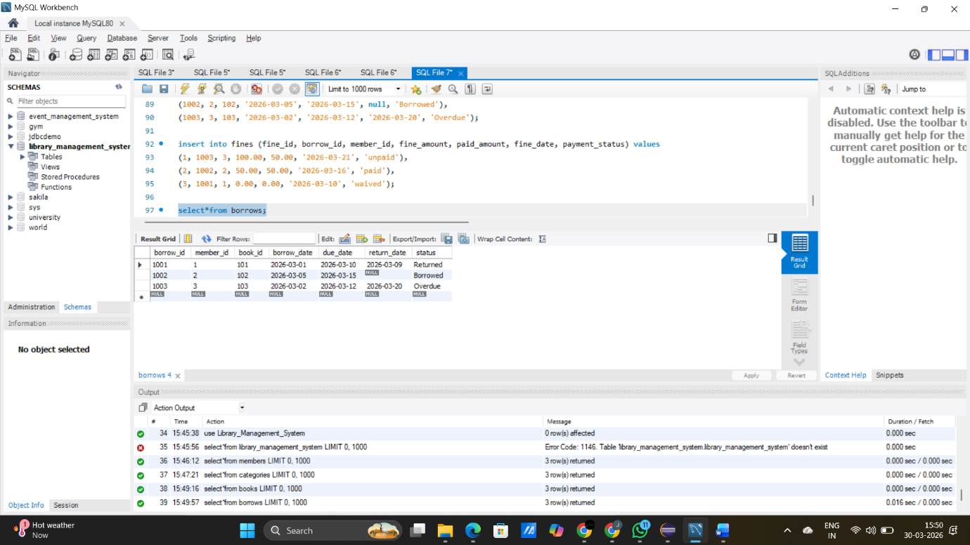

insert into fines (fine_id, borrow_id, member_id, fine_amount, paid_amount, fine_date, payment_status) values
(1, 1003, 3, 100.00, 50.00, '2026-03-21', 'unpaid'),
(2, 1002, 2, 50.00, 50.00, '2026-03-16', 'paid'),
(3, 1001, 1, 0.00, 0.00, '2026-03-10', 'waived');

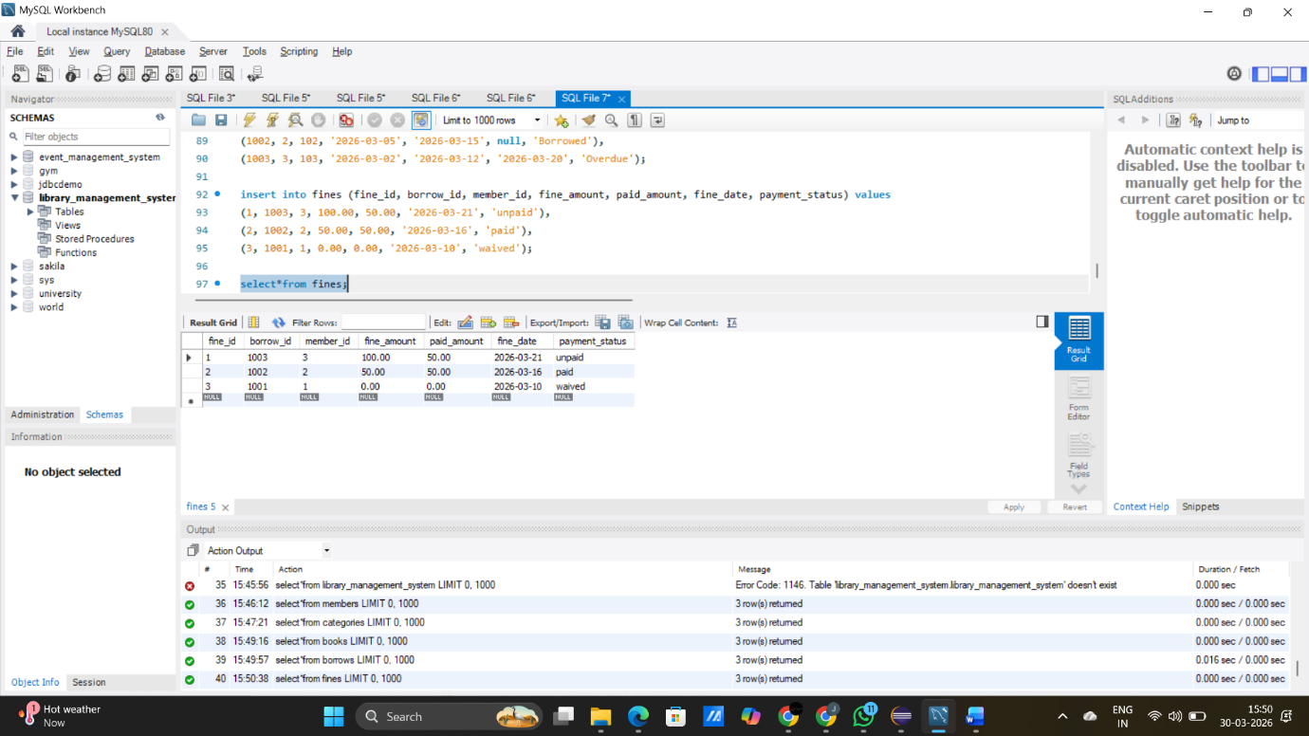

2. create database hr1;
use hr1;

create table employee(
employee_id int primary key,
first_name varchar(20),
last_name varchar(20),
year_of_experience int,
city varchar(50),
country_id varchar(10),
salary int,
commission decimal(5,2),
department_id int,
job_id varchar(20)
);

insert into employee(employee_id,first_name,last_name,year_of_experience,city,country_id,salary,commission,department_id,job_id)
values(101,'Darshan','Raj',28,'Tamil Nadu', 'India', 200000,20,1001,2001),
(102,'Prasana','KC',30,'Tamil Nadu', 'India', 500000,30,1002,2002),
(103,'Vetri','vel',35,'Tamil Nadu', 'India', 1000000,30,1003,2003);

select country_id, count(city) as number_of_cities from employee group by country_id;

select first_name,last_name,year_of_experience from employee where year_of_experience > 27;

select job_id from employee group by(job_id) having avg(salary) > 10000;

